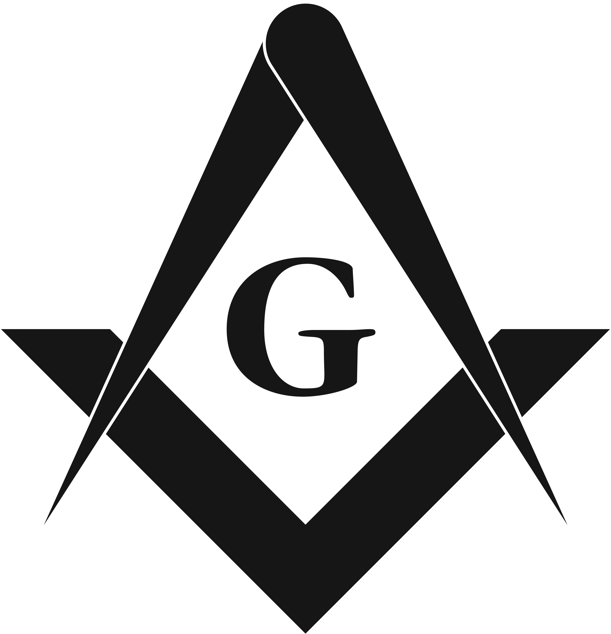
Ashlar College of Freemasonry
Grand Lodge of British Columbia and Yukon

Frequently Asked Questions

What qualifications do I need to join the Ashlar College of Freemasonry?
Our ACF constitution will allow Master Masons to register. There are no academic qualifications required by the students. All Master Masons eager to learn more about our fraternity at their leisure, are welcome to join us. There are no age restrictions. Brethren who have just attained the degree of a Master Mason as well as those who have been members of our fraternity for many years are welcome to join us.

Are we graded on our work?
No, you are not marked or graded on your assignments. There is no pass and fail. The courses are intended for the student to read, reflect and respond to the material provided. There may be occasions when the adjudicator of the course will ask you to rethink your responses to part or all of the assignment, which may in turn require you to re-write some of the work. Each adjudicator wishes to ensure that the student has gained an understanding of the course material. Through phone or e-mail, items of this nature can be discussed, and the student will gain more satisfaction from a fuller understanding of the content.

Who reads our assignments?
Each course is assigned to an adjudicator. He is identified to you when the course work arrives at your computer. You work with the adjudicator during the time you study a particular course. He responds to your work with commentary. Once completed, he informs the Dean who then sends the next course work to you.

How much time is required to complete the courses?
This depends on the time you have. The Directors and organizers of the courses believe that each level of the college (consisting of 6 courses) can be completed comfortably in a year. It does depend on the amount of time each student has to work through the assignments. Some courses can be completed faster than others. The Constitution of the College give a maximum time limit of 5 years to complete all the course work. Discretion is given to the Dean to extend the time under special circumstances.

How many levels are there?
There are three levels each containing 6 courses. Of the 6 courses, two are about History, two are on Governance and two explore Symbolism. There is an intended guidance that earlier courses are easier than the later courses in any of the three levels, but that does not always apply.

I understand there is a Dean. What is his job?
The Dean is the administrator of the College. He job is threefold. He receives registrations and fees for the courses, keeps records of courses completed by each student, and sends course material to students when they are ready to move on.

I have not studied any course work for a long time. What is available to help me get back to the discipline of studying course work?
It can be daunting to return to studying material for the first time after a long absence from that discipline. The Adjudicator can assist you on the course he is helping in. The Dean is also ready to assist you. There is access to brethren in your district whom are known to qualify to help as well. Again the Dean will seek brethren close to you to help if you require it.

